Band/General Music Days 27-31 (May 4-8)
Mr. Baker

**Strawberry delivery has been moved to May 22nd** Look for LiveGrade messages from me.

I am providing you with three options to choose from for your assignments. Choose the one that best fits your situation. Band students- You are to choose option 1- practice an instrument unless you do not have your instrument or are unable to play for some reason.

As you do your assignments, document them by either filling in a practice log or completing the assignments listed. Send me the documentation at the end of the week through LiveGrades or to my email: jsabaker@k12.wv.us
If you are unable to send me the documentation, keep it on paper and wait for further instructions on how to turn those in.

*Tip: If you use an email account other than LiveGrades you should be able to attach multiple files to an email. LiveGrades limits you to three attachments.

The packets/exercises, etc. are found at the following locations:
In This Packet! On the School website! I am LiveGrading them to you!

The three options you have are:

Option 1- Practice your instrument. Log the date, time and what your practice for the week and submit to my LiveGrades or email: jsabaker@12.wv.us
Practice any music or instrument that you may have at your house. If you have another instrument such as a piano, guitar, etc. you may play that and count it as practice time. Music is available on the band website: https://sites.google.com/site/emsbandwv
If you are unable to access that site please LiveGrade me and I can send you scales sheets and other warm-ups to practice.

Option 2- Do the Activities listed on the Musical Ideas sheet in this packet.

Option 3- Do the paper option listed at the bottom of the Musical Ideas sheet in this packet.

Choir students who do band!!- If you are doing an activity for Mrs. Dennis you may count that activity for your band work. Document it and send it to both Mrs. Dennis and myself. If you are unable to send documentation, keep the paper copy and await further instruction.

Packet 27-31 May 4 - May 8, 2020 Musical Ideas
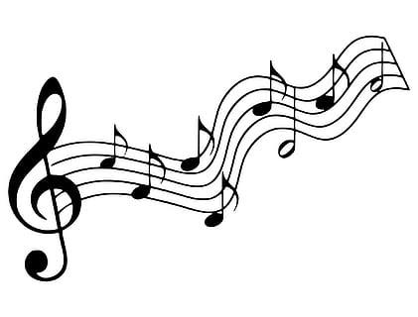
4  * Check out this Flash Mob of the  “1812 Overture”.  https://safeYouTube.net/w/VFL5  What do you think the audience thought about this surprise performance? | 5  * These girls are very talented! The style of music they’re playing is called “Boogie Woogie”.  https://safeYouTube.net/w/xWE4  Check out the history of Boogie Woogie here:  https://safeYouTube.net/w/XWE4  Does this style of music make you want to dance? | 6  *Harvard University has a BoomWhacker performance group!  https://safeYouTube.net/w/6jJ6  Could you name all three songs they played? Do you think they had to practice a lot to get so precise? | 7  * The Vancouver Youth Choir is fantastic! Here they are performing “Rise Up”.  https://safeYouTube.net/w/e3L7  What did you feel when you watched this performance? How would you describe each of the soloists’ voices? | 8  * Wow! Watch these vocalists create the soundtrack to a Honda Civic Commercial  https://safeYouTube.net/w/5UE4  Does this clip make you listen more carefully to the sounds in commercials? Or shows?
*Wish someone “May the 4th be with you” in honor of Star Wars.  Tell someone that May 4 is informally observed as "Dave Brubeck Day". May 4 is written "5/4," recalling the time signature of "Take Five", Brubeck's best known recording which is written in a 5/4 time signature. | * Listen to a piece of music without words (instrumental), and then make up a story to go along with the music | * Go outside.  Take a few deep breaths and relax.  What musical sounds do you hear? | * What artwork or doodle can you make starting with a Bass Clef? 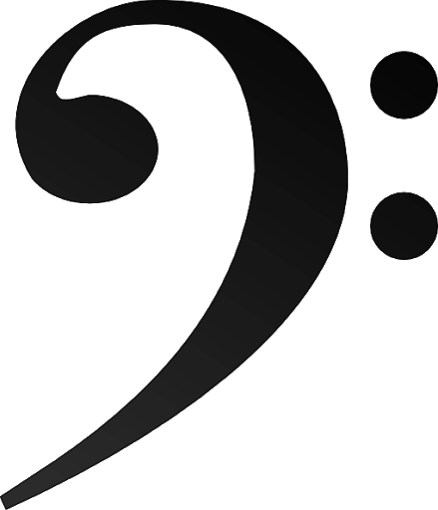How about with 4 sixteen notes?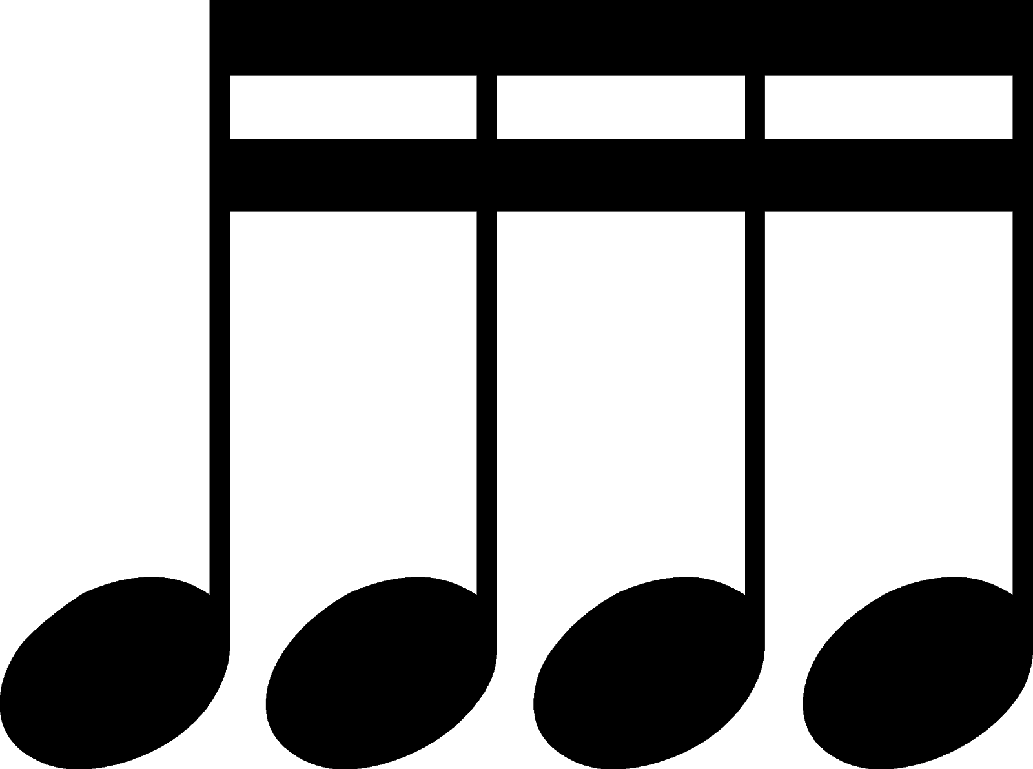 | * Listen to the sounds in your house other than the TV or someone talking or playing, what other sounds do you hear?
Name:
Grade: | Instrument:
Type of Activity or What was Practiced
Date: Time:  Activity: | Date: Time:  Activity:
Date: Time:  Activity: | Date: Time:  Activity:
Date: Time:  Activity: | Date: Time:  Activity:
Date: Time:  Activity: | Date: Time:  Activity:
Date: Time:  Activity: | Date: Time:  Activity:

Practice Guidelines
If you choose to practice an instrument that is great! Making music is a great way to focus, reduce stress and even relax you.
You are allowed to practice any instrument that you have available to you and may count it as work for band class.
Use the practice log that was provided in this packet to log the date, amount of time and what you practiced.

Ideas of what to practice.
I have put numerous exercises, resources and fundamental packets on the band website:
https://sites.google.com/site/emsbandwv
If you can explore the site and see what you can play.

Do the following exercises either daily or every other day:
- Long tones. Hold notes out for at least 4-8 beats. Make the best sound possible on your instrument. These aren’t exciting but they work.
- Scale exercises. Play them slowly. Play them as fast as you can. Push yourself for speed and accuracy. Play the whole scale or play 1-5. Play the scale in thirds: 1-2,1-3,1-4, etc.
See if you can make up patterns to play the scales.
- Brass- Do lip slurs. Do them slowly. When slurring from high to low think the syllable “eeh” to “ahh” for tongue position. Slur from low to high “ahh” to “eeh”. Do not use pressure on the lips.
- Brass can buzz on the mouthpieces. Try to do an easy song: “Hot Cross Buns” by buzzing.
- Woodwinds- Clar./Sax play on just your mouthpiece.
Clarinets if you play just the mouthpiece and barrel the sound should be a F# on a tuner.
Saxes if you just play the mouthpiece the sound should be an A on a tuner.
Flutes play the headjoint only and see if you can get a nice steady tone.
- Percussion be exact with your stick grip and rebound. Only rebound a maximum of 8 inches. Use your wrists only. Practice using a metronome. Keep a steady beat. Diddles, paradiddles.

If you only have a couple of pieces of music to play, experiment with playing it as many different ways as possible. Play it as fast as you can, as slow as you can, as soft as you can, as loud as you can. How far can you play before you have to take a breath?

