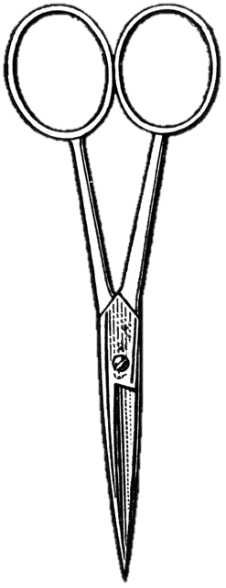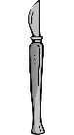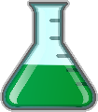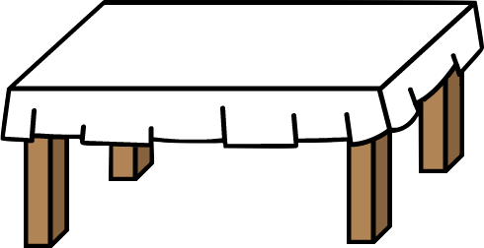***Featuring:***Live this Week

**Science Menu**

“ “The Lyrids Meteor Shower” and “Earth Day 2020”

**Note:** You must choose options that equal at least a $10 meal

*Substitutions may be possible, check with the owner Mrs.Corley (amy.corley@k12.wv.us)*

$1 Appetizers

$3 Sides

Describe the difference between an asteroid and a meteor; this page from NASA can help <https://spaceplace.nasa.gov/asteroid-or-meteor/en/>

Comets vs Asteroids

Watch a Brainpop on Comets and a Brainpop on Asteroids explain the difference between them. You can use a dictionary or encyclopedia to research.sm

Do something positive for Earth Day 2020

Clean up litter in your area, take a hike, use a refillable water bottle, recycle, make a poster to display, participate in virtual Earth Day, read about the history of Earth Day.

Read about environmental changes happening since social distancing started and write a paragraph about it.

Suggestions include: Himalayas are now visible; Ship wrecks in the Great Lakes stopped, better air quality, halting recycling

Calculate your Carbon Footprint (there are lots of online options) & plan THREE ways to reduce your carbon use. An offline options would be to make a list of things you personally could do to improve the environment.

Be a Citizen Scientist

The WV DNR has a project to track Eastern Box Turtles, check it out at wvexplorer.com. What did you learn? Have you seen any?

Read through the Power Point Presentation on the “Pacific Garbage Patch” and answer the worksheet questions. This is a good offline assignment option.

Watch a science documentary/show or read a science article and write a paragraph telling me about it.

Disney, Amazon, Hulu, and Netflix all have some wonderful options, shows like “Wild Kratts” count too. Check out newspaper articles.

Watch one TED Talk & write a paragraph about it.

Suggestions are: Unseen Footage, Unseen Nature; Nature. Beauty; Gratitude; My wish: Protect our oceans; Can wildlife adapt to climate change?

$4 Entrees

**Look for Shooting Stars**

**The Lyrids Meteor Shower peaks in the early morning hours of 4/22. Head outside and do some observations.** Were you able to see any meteors?

Be a Citizen Scientist

Download the Earth Challenge 2020 mobile app and begin collecting data on plastic pollution and air quality.

What information were you able to submit?

Do Something Positive for Earth Day 2020

Read Don’t Stream Something, Fix or DIY Something, Plant Something, Observe Spring (birds, plants, weather)

$2 Desserts