Packet 22- 31/Final Packets
Soc. St- Mrs. Guire
Orange Team

- Continue to work on your journal or time capsule
- Select 1 of the social studies videos from the chart to watch. They are on your WV PBS channel. (24) Live grade me which one you watched. If unable to find the show, live grade me which one you tried to view. Hope PBS sticks to the schedule 😊
4/28 4/29 4/30 5/1 5/2 5/3 5/4 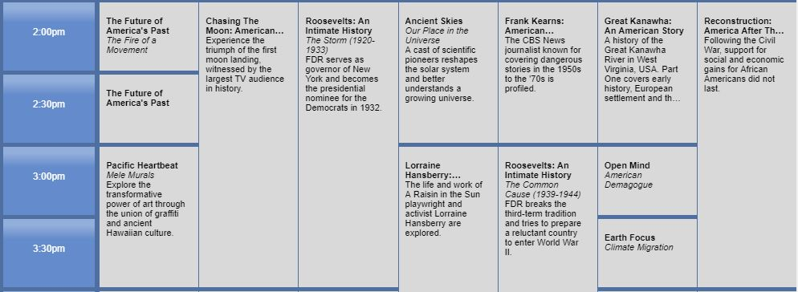
- Select and watch 2 Brain Pops in US History that interest you and send them to my email just like the others or make a flyer that shows healthy/safe tips for this Pandemic time. Neat and colored.

