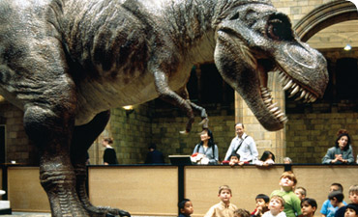

Animatronics

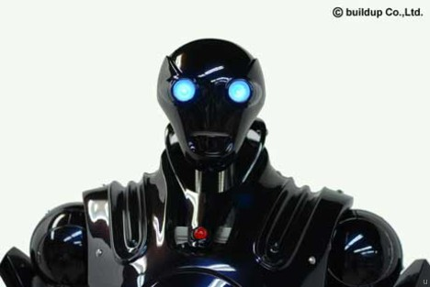

Name: _______________________________________
Date: _________________________________________

READING

Have you ever wondered how movie makers create life-like characters for their films? They often use something called 'animatronics' which involves making robots.

In movies, characters like dinosaurs, reindeer and aliens are made to look they are real. That's because they're robotic puppets called 'animatronics'. Animatronics are designed to create the illusion that they're real. It's a technique that was developed in the 1960s by Walt Disney.

Animatronics is the use of mechatronics to create machines which seem real rather than robotic. Animatronic creations include animals (including dinosaurs), plants and even mythical creatures.
A robot designed to be a convincing imitation of a human is specifically known as an android.
Animatronics is mainly used in movie making, but also in theme parks and other forms of entertainment.
The technology behind animatronics has become more advanced and sophisticated over the years, making the puppets even more realistic and lifelike.
Animatronics is used in situations where a creature does not exist, the action is too risky or costly to use real actors or animals, or the action could never be obtained with a living person or animal.
Animatronic systems can be implemented using both computer control and human control.

FILMS THAT HAVE USED ANIMATRONICS
- Jaws
- Jurassic Park
- King Kong
- Night at the Museum
- Star Wars
- Muppets
- Pirates of the Caribbean
- Alice in Wonderland
- Ninja Turtles

COMPREHENSION
1. Have you ever seen a film with animatronics? ____________
2. Write down a character that may be made in animatronics?
___________________
3. What is the robot called that is supposed to look human?
___________________
4. Animatronics is used in movies and _________________.
5. When was animatronics first developed? _____________
6. Do you think animatronics is a good invention? Why?
_________________________________________________
_________________________________________________
_________________________________________________
_________________________________________________

ALPHABETICAL ORDER
Place the movies in alphabetical order
A B C D E F G H I J K L M N O P Q R S T U V W X Y Z
____________________________
____________________________
____________________________
____________________________
____________________________
____________________________
____________________________
____________________________
____________________________
SPELLING
WORD | PRACTISE | TEST
movies
animals
create
life-like
human
more
computer
WRITING
Write sentences using the spelling words.
1. _______________________________________________________
2.________________________________________________________
3.________________________________________________________
4.________________________________________________________
5. _______________________________________________________
6. _______________________________________________________
7. _______________________________________________________
If you could make a robot what would it be? ______________
Draw it below

Animatronics

A | T | M | R | D | X | R | S | P | C | A | A | E | M | T
N | E | Z | U | E | A | C | T | T | N | T | K | E | E | V
D | Q | Q | A | F | E | S | O | I | O | I | Y | P | W | I
R | I | T | S | T | V | D | M | M | L | B | P | N | F | O
O | G | N | O | X | J | A | N | E | P | U | O | M | J | F
I | S | O | N | H | L | V | F | I | P | U | O | R | J | L
D | L | S | I | N | U | I | C | R | E | A | T | U | R | E
I | J | R | D | N | L | M | C | O | R | R | W | E | J | M
Q | Y | E | N | S | I | D | A | G | E | W | O | X | R | B
R | O | P | T | C | C | A | U | N | A | H | X | S | N | Y
S | H | C | I | F | U | N | L | D | L | P | U | Y | Y | L
Q | N | S | C | I | N | O | R | T | A | M | I | N | A | G
Y | H | H | B | G | M | S | S | S | N | Q | J | A | X | Q
B | Z | E | K | D | V | N | B | P | L | A | N | T | S | M
E | V | H | K | X | H | J | H | B | M | U | C | X | P | U

ANDROID | ANIMAL | ANIMATRONICS
COMPUTER | CREATURE | DINOSAUR
DISNEY | HUMAN | LIFELIKE
PERSON | PLANTS | PUPPET
REAL | REINDEER | ROBOTS

