Snow Day Packet for Choir
Mrs. Dennis

If there is a snow day, below are some activities for you to complete. Please select only one activity per snow day and return the work to Mrs. Dennis the next day we have school. If you have any questions, you can send me a message on Livegrades.

Option A:
Music Listening. Listen to a style of music of your choice for 20 minutes and write a brief description of the music on the Snow Day Log included in this packet. Please include what you listened to (names of songs and artists), the style, how it made you feel, and what it made you think about. Please have your parents sign or initial the Snow Day Log when you have finished.
Option B:
Rehearsing Choral Literature. Practice singing and/or memorizing the songs we are working on in choir class for at least 20 minutes. Attached to this (and in Livegrades) are links to most of our songs. Don’t forget to have your parents sign or initial the Snow Day Log.
Option C:
Online Music Websites. Choose one of the websites below and work on it for at least 20 minutes. Please record what website you went to and what activities you completed. Make sure to have your parents sign or initial the Snow Day Log when you have finished.
http://musictechteacher.com/
https://www.musictheory.net/
http://meholickmusic.webs.com/
https://learningmusic.ableton.com/
Option D:
Activity Page. Complete and turn in one of the attached music worksheets.
(No need to fill out a log for option D, just turn in worksheet)

Name: _________________________________
Class Period: __________
Date: ___________
Snow Day Music Log for Choir
Circle Assignment Option:
A. Music Listening B. Rehearsing Choral Literature C. Online Music Websites

List Music/Websites/etc: _________________________________________________________
______________________________________________________________________________
______________________________________________________________________________
______________________________________________________________________________
Time Spent on Activity: ___________ Parent Signature: ______________________________
--------------------------------------------------------------------------------------------------------------------------------
Cut pages apart here
Name: _________________________________
Class Period: __________
Date: ___________
Snow Day Music Log for Choir
Circle Assignment Option:
A. Music Listening B. Rehearsing Choral Literature C. Online Music Websites

List Music/Websites/etc: _________________________________________________________
______________________________________________________________________________
______________________________________________________________________________
______________________________________________________________________________
Time Spent on Activity: ___________ Parent Signature: ______________________________

Name: _________________________________
Class Period: __________
Date: ___________
Snow Day Music Log for Choir
Circle Assignment Option:
A. Music Listening B. Rehearsing Choral Literature C. Online Music Websites

List Music/Websites/etc: _________________________________________________________
______________________________________________________________________________
______________________________________________________________________________
______________________________________________________________________________
Time Spent on Activity: ___________ Parent Signature: ______________________________
--------------------------------------------------------------------------------------------------------------------------------
Cut pages apart here
Name: _________________________________
Class Period: __________
Date: ___________
Snow Day Music Log for Choir
Circle Assignment Option:
A. Music Listening B. Rehearsing Choral Literature C. Online Music Websites

List Music/Websites/etc: _________________________________________________________
______________________________________________________________________________
______________________________________________________________________________
______________________________________________________________________________
Time Spent on Activity: ___________ Parent Signature: ______________________________

Name: _________________________________
Class Period: __________
Date: ___________
Snow Day Music Log for Choir
Circle Assignment Option:
A. Music Listening B. Rehearsing Choral Literature C. Online Music Websites

List Music/Websites/etc: _________________________________________________________
______________________________________________________________________________
______________________________________________________________________________
______________________________________________________________________________
Time Spent on Activity: ___________ Parent Signature: ______________________________
--------------------------------------------------------------------------------------------------------------------------------
Cut pages apart here
Name: _________________________________
Class Period: __________
Date: ___________
Snow Day Music Log for Choir
Circle Assignment Option:
A. Music Listening B. Rehearsing Choral Literature C. Online Music Websites

List Music/Websites/etc: _________________________________________________________
______________________________________________________________________________
______________________________________________________________________________
______________________________________________________________________________
Time Spent on Activity: ___________ Parent Signature: ______________________________

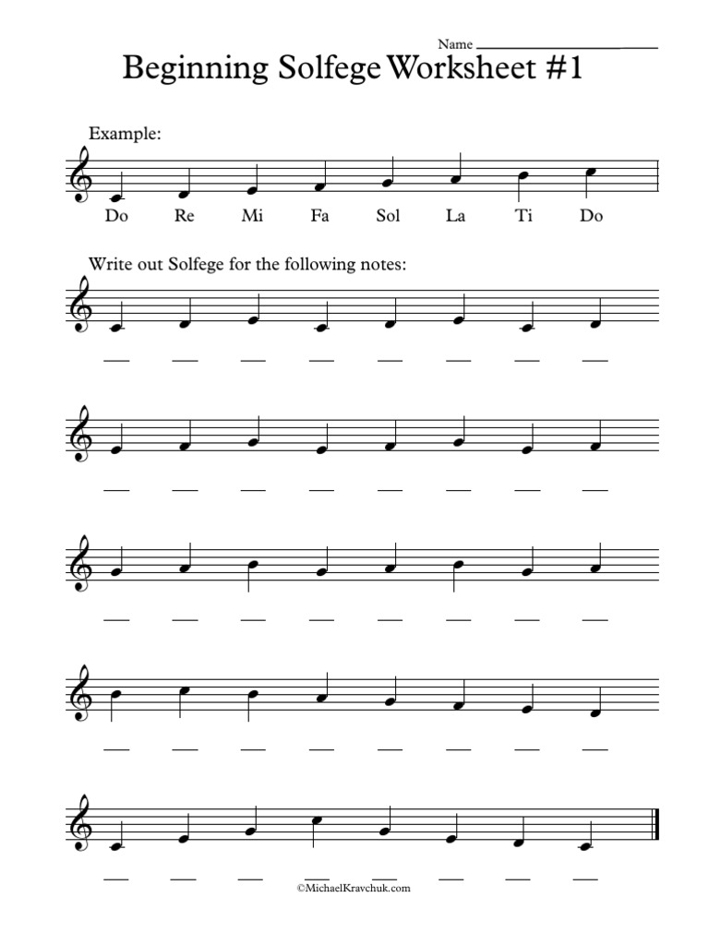
Name: __________________________
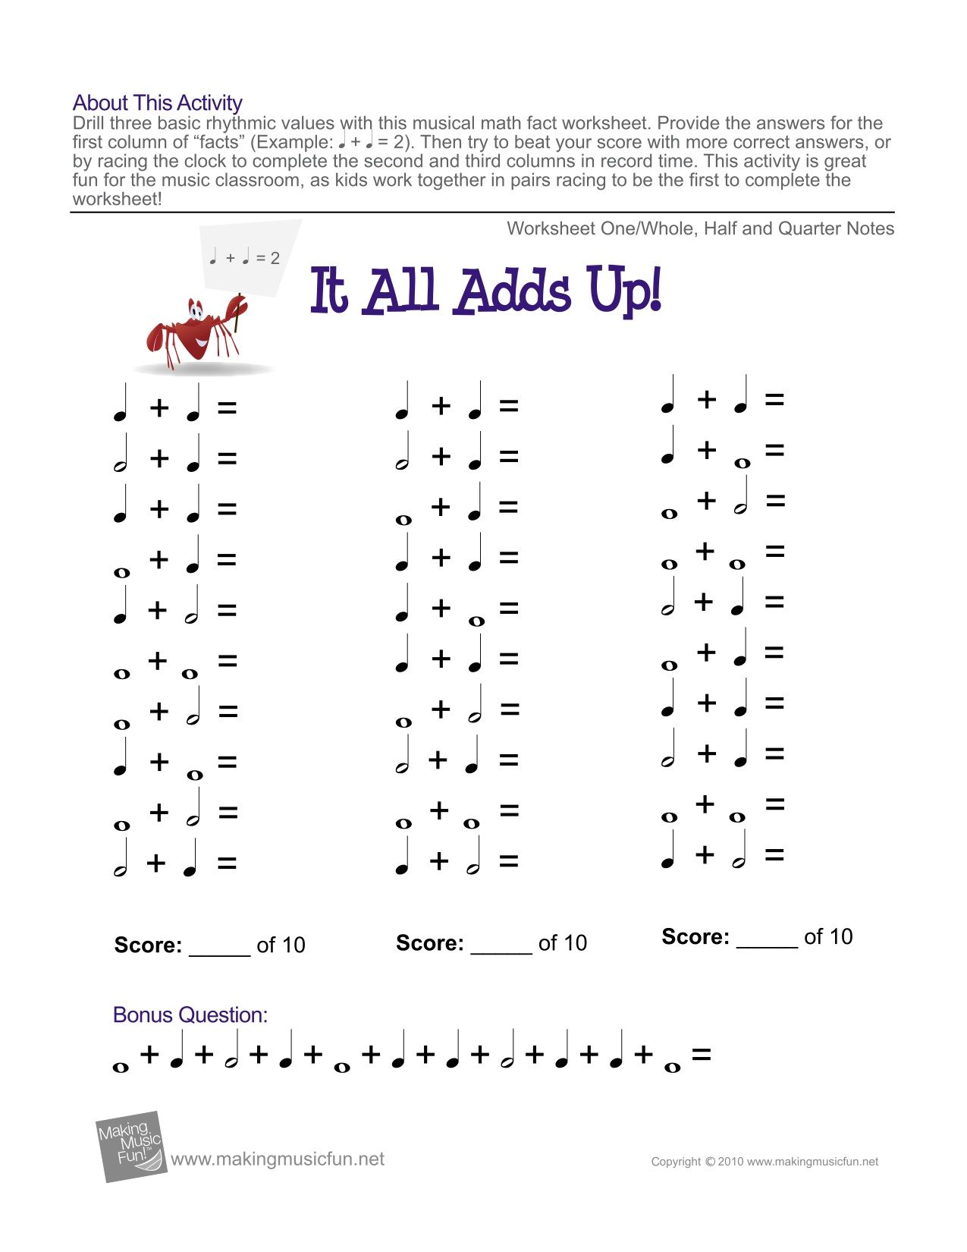
Christmas Concert Selections:
All Choirs
Solfege Santa https://www.jwpepper.com/sheet-music/media-player.jsp?&type=audio&productID=10092605
A Bit of Holiday Cheer https://www.jwpepper.com/sheet-music/media-player.jsp?&type=audio&productID=3284171
6th Grade
Be a Candle of Hope https://www.jwpepper.com/sheet-music/media-player.jsp?&type=audio&productID=10028869
Hot Chocolate https://www.jwpepper.com/sheet-music/media-player.jsp?&type=audio&productID=10048833
Where Are You Christmas? https://www.jwpepper.com/sheet-music/media-player.jsp?&type=audio&productID=10048879
Still Still Still https://www.jwpepper.com/sheet-music/media-player.jsp?&type=audio&productID=10049518
Hannukkah Shalom https://www.jwpepper.com/sheet-music/media-player.jsp?&type=audio&productID=10457257
All I Want Is… Nuttin’! https://www.jwpepper.com/sheet-music/media-player.jsp?&type=audio&productID=10089097
7th Grade
Starry Night of Winter https://www.jwpepper.com/sheet-music/media-player.jsp?&type=audio&productID=10278937
Sing We All Noel https://www.jwpepper.com/sheet-music/media-player.jsp?&type=audio&productID=10010895
Christmas Time is Here https://www.jwpepper.com/sheet-music/media-player.jsp?&type=audio&productID=10030208
Holly, Jolly Christmas https://www.jwpepper.com/sheet-music/media-player.jsp?&type=audio&productID=10088527
8th Grade
Let It Snow! Let It Snow! Let It Snow! https://www.jwpepper.com/sheet-music/media-player.jsp?&type=audio&productID=10274485
Carol of the Bells
Christmas Bells are Ringing https://www.jwpepper.com/sheet-music/media-player.jsp?&type=audio&productID=3282191
Mary Had a Baby
Nutcracker Jingles https://www.jwpepper.com/sheet-music/media-player.jsp?&type=audio&productID=10047192

