Snow Day Packet for General Music
Mrs. Dennis

If there is a snow day, below are some activities for you to complete. Please select only one activity per snow day and return the work to Mrs. Dennis the next day we have school. If you have any questions, send me a message through Livegrades.

Option A:
Music Listening. Listen to a style of music of your choice for 20 minutes and write a brief description of the music on the Snow Day Log included in this packet. Please include what you listened to (names of songs and artists), the style, how it made you feel, and what it made you think about. Please have your parents sign or initial the Snow Day Log when you have finished.
Option B:
Online Music Websites. Choose one of the websites below and work on it for at least 20 minutes. Please record what website you went to and what activities you completed. Make sure to have your parents sign or initial the Snow Day Log when you have finished.
http://musictechteacher.com/
https://www.musictheory.net/
http://meholickmusic.webs.com/
https://learningmusic.ableton.com/
http://www.sfkids.org
Option C:
Instrument Practice. If you have an instrument, spend time (at least 20 minutes) practicing that instrument. Log your time and what you practiced (the instrument and the music you played) on your Snow Day Log. Have a parent sign or initial when you have finished.

Option D:
Activity Page. Complete and turn in one of the attached music worksheets.
(You do not need to complete a log for this, just turn in the worksheet)

Name: _________________________________
Class Period: __________
Date: ___________
Snow Day Music Log for General Music
Circle Assignment Option:
A. Music Listening B. Online Websites C. Instrument Practice

List Music/Websites/etc: _________________________________________________________
______________________________________________________________________________
______________________________________________________________________________
______________________________________________________________________________
Time Spent on Activity: ___________ Parent Signature: ______________________________
--------------------------------------------------------------------------------------------------------------------------------
Cut pages apart here
Name: _________________________________
Class Period: __________
Date: ___________
Snow Day Music Log for General Music
Circle Assignment Option:
A. Music Listening B. Online Websites C. Instrument Practice

List Music/Websites/etc: _________________________________________________________
______________________________________________________________________________
______________________________________________________________________________
______________________________________________________________________________
Time Spent on Activity: ___________ Parent Signature: ______________________________

Name: _________________________________
Class Period: __________
Date: ___________
Snow Day Music Log for General Music
Circle Assignment Option:
A. Music Listening B. Online Websites C. Instrument Practice

List Music/Websites/etc: _________________________________________________________
______________________________________________________________________________
______________________________________________________________________________
______________________________________________________________________________
Time Spent on Activity: ___________ Parent Signature: ______________________________
--------------------------------------------------------------------------------------------------------------------------------
Cut pages apart here
Name: _________________________________
Class Period: __________
Date: ___________
Snow Day Music Log for General Music
Circle Assignment Option:
A. Music Listening B. Online Websites C. Instrument Practice

List Music/Websites/etc: _________________________________________________________
______________________________________________________________________________
______________________________________________________________________________
______________________________________________________________________________
Time Spent on Activity: ___________ Parent Signature: ______________________________

Name: _________________________________
Class Period: __________
Date: ___________
Snow Day Music Log for General Music
Circle Assignment Option:
A. Music Listening B. Online Websites C. Instrument Practice

List Music/Websites/etc: _________________________________________________________
______________________________________________________________________________
______________________________________________________________________________
______________________________________________________________________________
Time Spent on Activity: ___________ Parent Signature: ______________________________
--------------------------------------------------------------------------------------------------------------------------------
Cut pages apart here
Name: _________________________________
Class Period: __________
Date: ___________
Snow Day Music Log for General Music
Circle Assignment Option:
A. Music Listening B. Online Websites C. Instrument Practice

List Music/Websites/etc: _________________________________________________________
______________________________________________________________________________
______________________________________________________________________________
______________________________________________________________________________
Time Spent on Activity: ___________ Parent Signature: ______________________________

Name: _______________________________
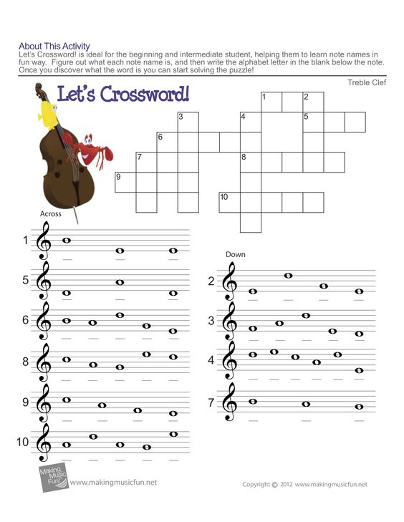
Name: ____________________________
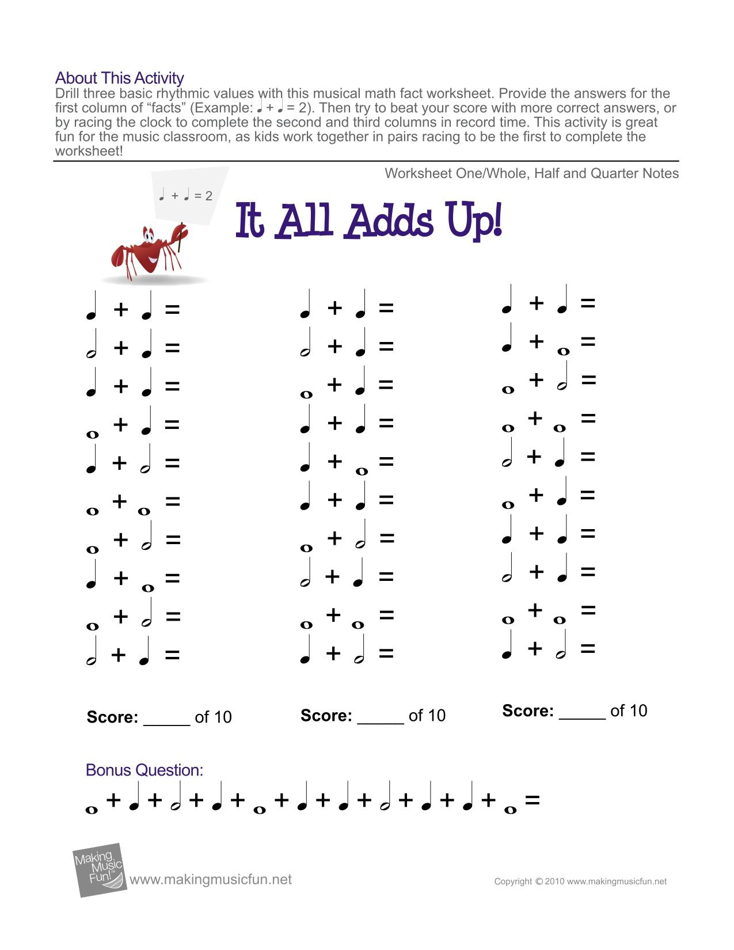

Name: ____________________________

Date: ____________
